KJSCE/IT/TY B Tech/SEMVI/SM/2021-22

**Experiment No.: 5**

**Title:** Single Server system (One-operator Barbershop problem) using a general purpose language

**(Autonomous College Affiliated to University of Mumbai)**

KJSCE/IT/TY B Tech/SEMVI/SM/2021-22

**Batch:A4**

**Roll No.:1914078**

**Experiment No.:5**

**Aim:** To simulate a Single Server system (One-operator Barbershop problem) using a general purpose language

**___________________________________________________________________________**

**Resources needed:** C / C++ / java

**___________________________________________________________________________**

**Theory**

**Problem Statement:**

Implement a single-server queuing system for which the interarrival times A1,A2….are

independent and identically distributed (IID) random variables. A customer who arrives and finds the server idle enters service immediately, and service times S1,S2….of the successive

customers are IID random variables that are independent of the interarrival time. A customer who arrives and finds the server busy joins the end of the single queue. Upon completing service for a customer, the server chooses a customer from the queue (if any) in a first-in, first-out (FIFO) manner.

The simulation will begin in the “empty-and-idle” state. The simulation should stop when the nth customer enters service.

**Concepts:**

Software that is used to develop simulation models can be divided into three categories. First,there are general purpose languages,such as C,C++. Second,there are simulation programming languages,examples being GPSS,SIMSCRIPT. Third, there are number of simulation packages such as ARENA.

There are several reasons for choosing a general –purpose language, rather than more powerful simulation software, for introducing computer simulation at this point:

* By learning to simulate in a general-purpose language, one must pay attention to every detail.There will be a greater understanding of how simulations actually operate and thus less chance of conceptual errors if a switch is later made to high-level simulation package.
* Despite the fact that there is now very good and powerful simulation software available, it is sometimes necessary to write at least parts of complex simulations in a general-purpose language if the specific, detailed logic of complex systems is to be represented faithfully.
* General-purpose languages are widely available, and entire simulations are sometimes still written in this way.

**Characteristics of Queuing System:**

The key elements of queuing system are customers & servers. The term customer can refer to people, machines, and trucks. The server might refer to receptionist, person etc.

1. **Calling population**: The population of potential customer is referred to as calling population. In systems with large population the calling population is usually assumed to be infinity. E.g. population of potential customer of a bank.

**(Autonomous College Affiliated to University of Mumbai)**

KJSCE/IT/TY B Tech/SEMVI/SM/2021-22

The actual population may be finite. The main difference between finite & infinite population is based on the definition of the arrival rate.

1. **System Capacity**: The system capacity has no limit meaning that any no. of units comes and waits in the queue. In many queuing system there is a limit to the no. of customers that may be waiting.
2. **Nature of Arrivals**: Arrivals for service occur at a time in random fashion and once they join the waiting line, they are served.
3. **Service Mechanism:** The units are served in order of their arrival by a single server or a channel.
4. **Queuing Discipline:** It refers to the logical ordering of customers that will be chosen for service when a server becomes busy.
5. **State Of System:** It is the no. of units in the system & status of server (busy / idle).
6. **Events:** It is a set of circumstances that causes an instantaneous change in the state of system

Possible events in a single server system:

* + The Entry of a unit in the system.
  + Departure of unit from system on completion of service.

1. **Simulation Clock**: It is used to track simulation time.

**Conceptual Model:**

The One –operator barbershop is simulated by using a program written in a general-purpose language to record successive system snapshots as time advances. The simulation requires mainly a service time distribution and an interarrival time distribution of customers.

**Characteristics of Grocery Store checkout counter System:**

1. Calling Population: Infinite.
2. System capacity: Infinite.
3. Nature of Arrival: Random arrival exponentially distributed with mean 1 minute
4. Service Mechanism: At a time only one customer is served; service time is random, exponentially distributed with mean 0.5 minute
5. Queuing Discipline: FIFO.

**System State:**

1. Waiting time in queue.
2. Status of operator (Busy / Idle)
3. Time customer spends in the system.

**Entities:**

The entities in single channel queue are queue & server.

**(Autonomous College Affiliated to University of Mumbai)**

KJSCE/IT/TY B Tech/SEMVI/SM/2021-22

**Events:**

1. Arrival Event
2. Departure Event

**Activities:**

1. Interarrival time.
2. Service time.

**Delay:**

Waiting time in the queue.

**Stopping event:**

1000th customer enters service

**Use of Random Nos.:**

* For generating interarrival time
* For generating service time

**Real life Examples**:

1. Customers queuing in the Telephone Bill Payment System Customers form single channel queue. Customer is chosen in FIFO manner.

**Performance measures:**

1. **Average delay in queue** =(Total time customers wait in queue) / (Total no. of Customers)
2. **Probability. Of Customers waiting** =(No. of Customers who waits) / (Total no. of Customers)
3. **Server utilization** = (Total busy Time Of Server) / (Total runtime of simulation)
4. **Average Time between Arrival** = (Total Time between arrivals) / (No. of arrivals)
5. **Average Waiting Time of Those Who Wait** = (Total Time Customer waits in system) / (Total no. of Customers)
6. **Average Time Customers Spends In System** = (Total Time Customer spends in system) / (Total no. of Customers)

**Time simulation ends**

**__________________________________________________________________________**

**(Autonomous College Affiliated to University of Mumbai)**

KJSCE/IT/TY B Tech/SEMVI/SM/2021-22

**__________________________________________________________________________**

**Procedure / Approach /Algorithm / Activity Diagram:**

**Flowchart Arrival event:**

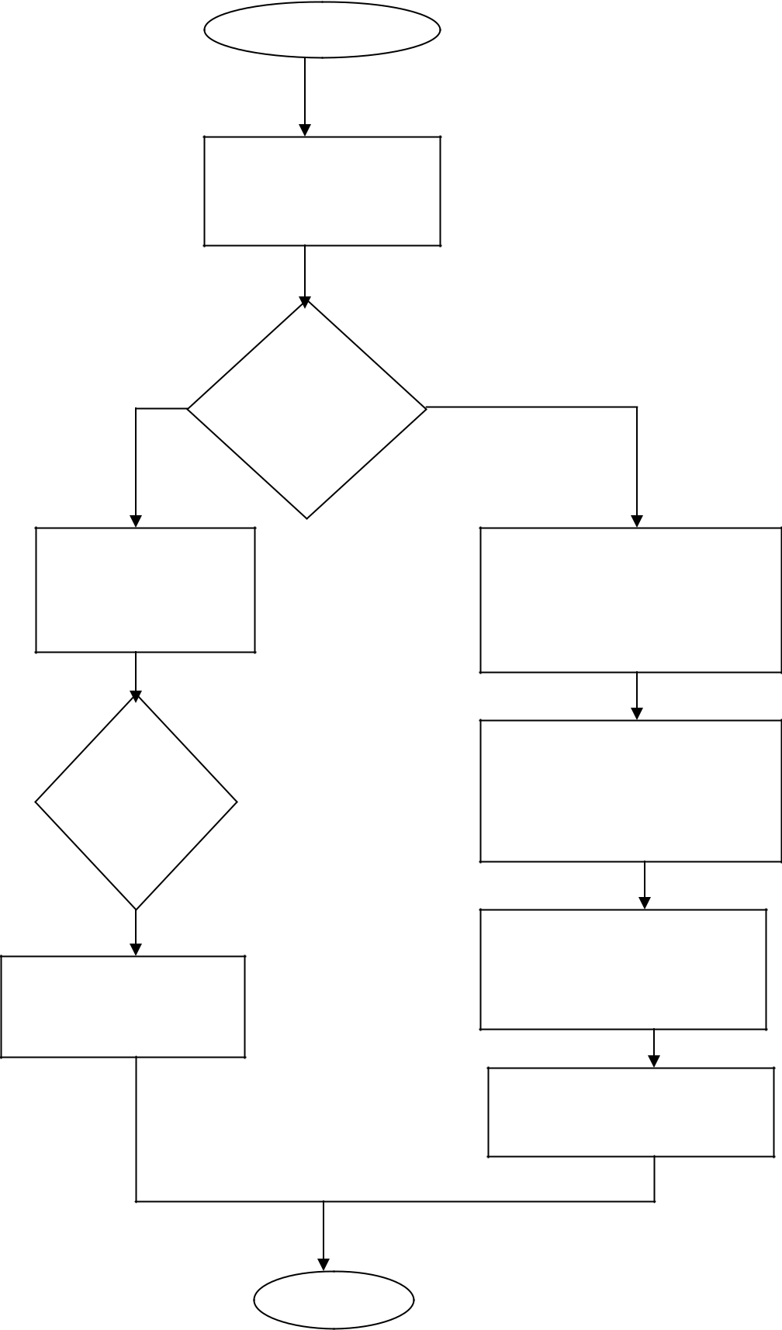

Arrival event

Schedule the next

arrival event

Is the

server

busy?

Add 1 to the

number in queue

Is the

queue

full?

Store time of arrival

of this customer

Set delay=0

For this customer and

gather statistics

Add 1 to the number of

customers delayed

Make the srver busy

Schedule a departure

event for this customer

Return

**(Autonomous College Affiliated to University of Mumbai)**

KJSCE/IT/TY B Tech/SEMVI/SM/2021-22

**Flowchart Departure event:**

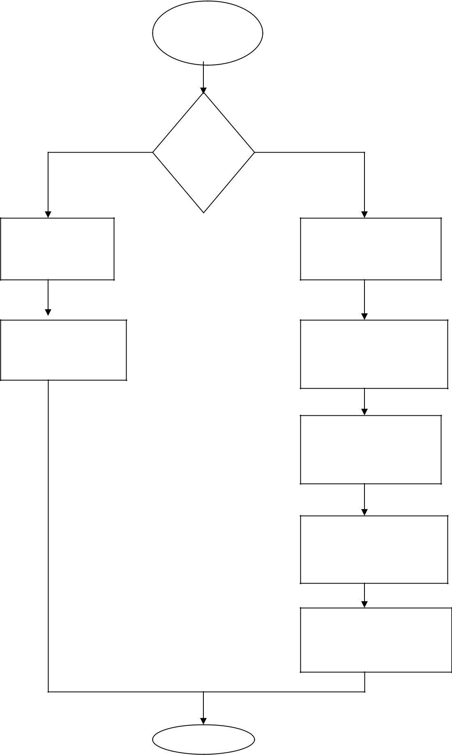

Departure

event

Is queue

empty?

Make the server

idle

Eliminate departure

event from the

consideration

Substract 1 from the

number in queue

Compute delay of

customer entering service

and gather statistics

Add 1 to the number of

customers delayed

Schedule a departure

event for this customer

Move each customer in

queue (if any)up one place

**(Autonomous**Return **College Affiliated to University of Mumbai)**

KJSCE/IT/TY B Tech/SEMVI/SM/2021-22

**___________________________________________________________________________**

**Results: (Program printout with output / Document printout as per the format)**

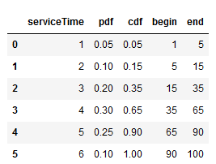

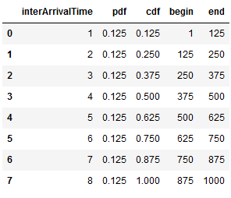

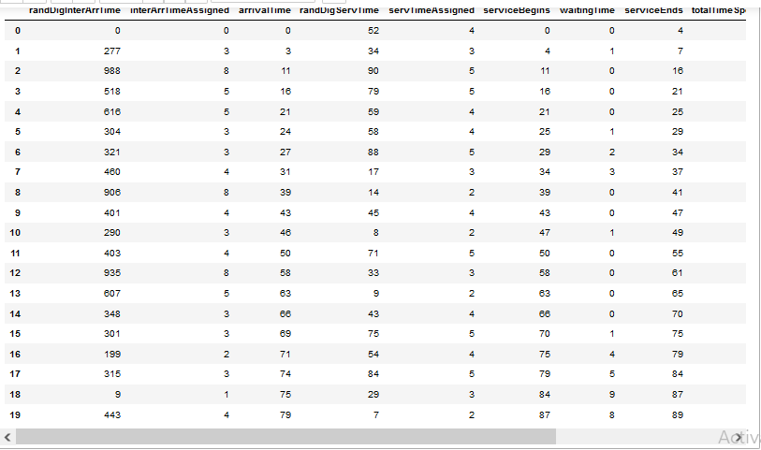

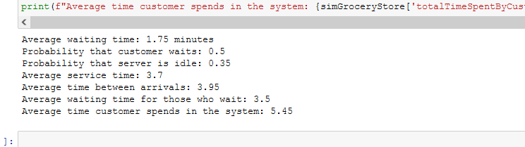

**_______________________________________________________________________**

**Questions:**

1. Name a few special purpose simulation languages and simulation packages?

Ans)

* Advanced Simulation Library - open-source hardware accelerated multiphysics simulation software.
* Algodoo - 2D physics simulator focused on the education market that is popular with younger users.
* ASCEND - open-source equation-based modelling environment.
* Cantera - chemical kinetics package.
* Celestia - a 3D astronomy program.
* CP2K - Open-source ab-initio molecular dynamics program.
* DWSIM - an open-source CAPE-OPEN compliant chemical process simulator.
* Elmer - an open-source multiphysical simulation software for Windows/Mac/Linux.
* Facsimile - a free, open-source discrete-event simulation library.
* FlightGear - a free, open-source atmospheric and orbital flight simulator with a flight dynamics engine (JSBSim) that is used in a 2015 NASA benchmark[1] to judge new simulation code to space industry standards.
* FreeFem++ - Free, open-source, multiphysics Finite Element Analysis (FEA) software.
* Freemat - a free environment for rapid engineering, scientific prototyping and data processing using the same language as MATLAB and GNU Octave.
* Gekko - simulation software in Python with machine learning and optimization
* GNU Octave - an open-source mathematical modeling and simulation software very similar to using the same language as MATLAB and Freemat.
* HASH - open-core multi-agent simulation software and package manager.

1. Name any two features that are relevant when selecting simulating simulation software.

Ans)

|  |  |
| --- | --- |
| **Syntax** | Easily,understood, consistent, unambiguous, English-like |
| **Input flexibility** | Accepts data from external files, databases, spreadsheets, or interactively |
| **Modeling conciseness** | Powerful actions, block, or nodes |
| **Randomness** | Random-variate generators for all common distributions, e.g…,,Exponential,Triangular,Uniform,Normal |

KJSCE/IT/TY B Tech/SEMVI/SM/2021-22

**___________________________________________________________________________**

**Outcomes:**

Apply the experimental process of simulation for model building using simulation languages and tools

**_________________________________________________________________________**

**Conclusion: (Conclusion to be based on outcomes)**

We conducted a simulation a single server system of a grocery store using Python, a general purpose language.

**_______________________________________________________________________**

**Grade: AA / AB / BB / BC / CC / CD /DD**

**Signature of faculty in-charge with date**

**___________________________________________________________________________**

**References:**

**Books/ Journals/ Websites:**

**Text Book:**

Banks J., Carson J. S., Nelson B. L., and Nicol D. M., “Discrete Event System Simulation”, 3rd edition, Pearson Education, 2001.

**Additional Web Resources:**

* Real Queuing Examples:[http://www2.uwindsor.](http://www2.uwindsor.ca/)ca/hlynka/qreal.html

This site contains excerpts from news articlesthat deal with aspects of waiting lines.

* ClearQ [:http://clearq.com/](http://clearq.com/) This company produces “take-a-number” systems for servicefacilities (e.g., delis), but also providesperformance information about the waiting line.
* Qmatic:[http://us.q-matic.com/index.](http://us.q-matic.com/index.html)htmlThiscompany produces informational displays andother products to keep customers informedabout waiting times.
* “Queuing Presentation” by Richard Larson, givenat the Institute for Operations Research and the

Management Sciences:http://caes.mit.edu/people/larson/MontrealINFORMS1/sld001.htm.

•The Queuing Theory Tutor

[:http://www.dcs.ed.ac.uk/home/jeh/Simjava/queueing/mm1](http://www.dcs.ed.ac.uk/home/jeh/Simjava/queuei)_q/mm1_q.html

This site has twoanimated displays of waiting lines. The user canchange arrival and service rates to see howperformance is affected.

**(Autonomous College Affiliated to University of Mumbai)**

KJSCE/IT/TY B Tech/SEMVI/SM/2021-22

• Myron Hlynka’s Queuing Page:http:www2.uwindsor.ca/hlynka/queue.html

This web site contains information about waiting linesas well as links to other interesting sites.

• Queuing ToolPak:http://www.bus.ualberta.ca/aingolfsson/qtp/

The Queuing ToolPak is an Excel add-in that allowsyou to easily compute performance measures fora number of different waiting line models

**(Autonomous College Affiliated to University of Mumbai)**